Circle WA October meeting photo report

The topics we enjoyed ;

1. Super Kabuki by Ennosuke and its fun English title,’Traveling alone along the Tokaido Highway.’

1. Halloween costume festival at Roppongi and Omotesando.

1. 3D printer and possibility of rapid improvement of technology.

1. Lastly Johnny Appleseed was introduced by Ritsuko in her Language Teaching Art workshop showing us a copy of a lovely autumn picture from a book. She read the beautiful poetic book and explained who Johnny was and what he did. *
It has been proved that her workshop meets the purpose of the Circle WA meeting; exchanging ideas and thought freely, thinking in English, expanding the expressions in English.

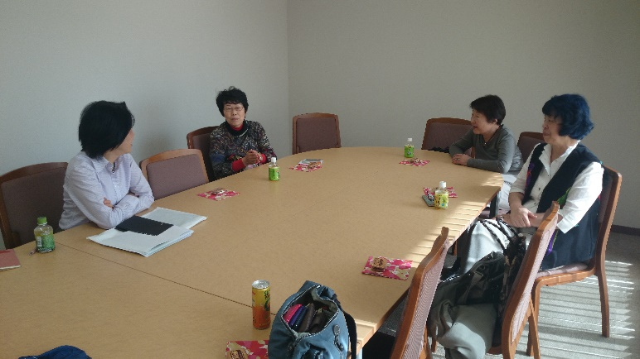
*John Chapman (September 26, 1774 – March 11, 1845), often called Johnny Appleseed, was an American pioneer nurseryman who introduced apple trees to large parts of Pennsylvania, Ohio, Indiana, and Illinois, as well as the northern counties of present day West Virginia. He became an American legend while still alive, due to his kind, generous ways, his leadership in conservation, and the symbolic importance he attributed to apples. He was also a missionary for The New Church (Swedenborgian)^{[1]} and the inspiration for many museums and historical sites such as the Johnny Appleseed Museum^{[2]} in Urbana, Ohio and the Johnny Appleseed Heritage Center^{[3]} in between Lucas, Ohio and Mifflin, Ohio.
