Circle WA September meeting photo report
Each attendee talked:
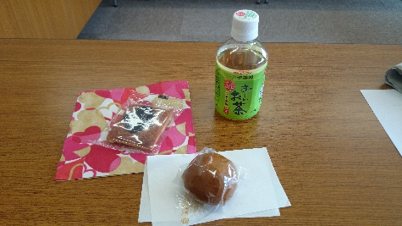
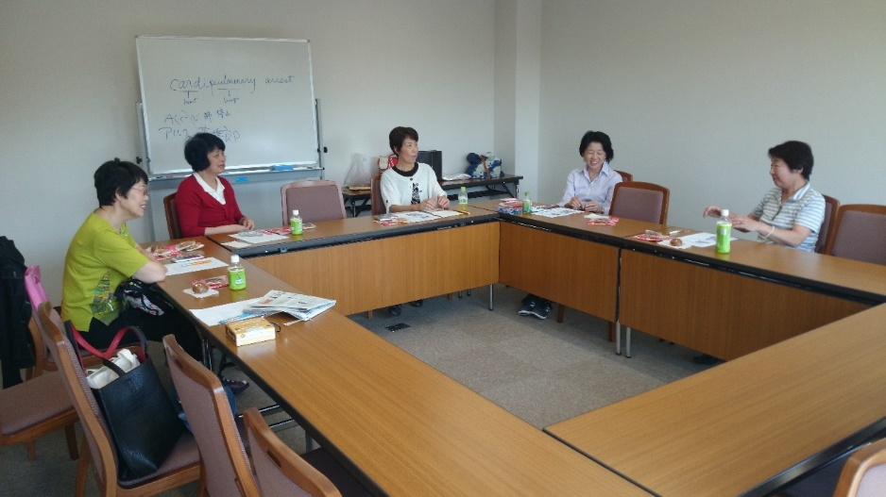

- A short speech on Ms Chie Imai, a world famous fur designer. She received Commander of the Lion of Finland last January 2014.
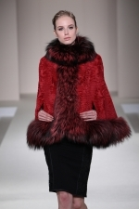
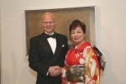

- Cleaning the son's room was exhausting. Gardeners came and I had to serve them tea with cakes three times a day.

- Went to Mt Asama which was one of 47 active volcanoes last Saturday and saw helicopters. Later I was informed of the tragedy of Mt Ontake. The eruption could have been at Mt Asama.

- An interesting bus travel from Mitaka to Futagotamagawa avoiding the confusing Shibuya Stn.

- Outstandingly beautiful park, Kinchakyda, near Koma Stn of Seibu Ikebukuro Line. The park is full of red and white spider lilies.
